Cairo University  
Faculty of Computers and Artificial Intelligent

**CS251**

**Software Engineering I**

Garage Parking System

Software Design

Maher mohsen bahig labib

Mario guirguis abdel-messeh

Kerolos geroge fayek nagib

Hazem adel khalel nabwy

May,2022

Contents_Toc101814919

Team 3

Document Purpose and Audience 3

System Models 4

I. Class diagrams 4

II. Sequence diagrams 6

Class - Sequence Usage Table 11

Ownership Report 12

Policy Regarding Plagiarism: 12

# Team

|  |  |  |  |
| --- | --- | --- | --- |
| **ID** | **Name** | **Email** | **Mobile** |
| 20200415 | Maher mohsen bahig labib | [-mezwmohsen@gmail.com](mailto:-mezwmohsen@gmail.com)  -11410120200415@stud.cu.edu.eg | -01287695176  -01001560655 |
| 20200405 | Mario guirguis abdel-messih | [-marioguirguis181@gmail.com](mailto:-marioguirguis181@gmail.com)  -11410120200405@stud.cu.edu.eg | -01550319008 |
| 20200399 | Kerolos george fayek nagib | [-kerolosgeorge290@gmail.com](mailto:-kerolosgeorge290@gmail.com)  -11410120200399@stud.cu.edu.eg | -01224587074 |
| 20200136 | Hazem adel khalel nabwy | [-hazemadelkhalel@gmail.com](mailto:-hazemadelkhalel@gmail.com)  -11410120200136@stud.cu.edu.eg | -01116104321 |

# Document Purpose and Audience

**Document Purpose:**

The purpose of this document is to show system design that were designed by the software engineer team, so in the next sections we show the design of every part of the system.

**Document Audience:**

* Project Manager
* developer
* tester

# System Models

## I. Class diagrams

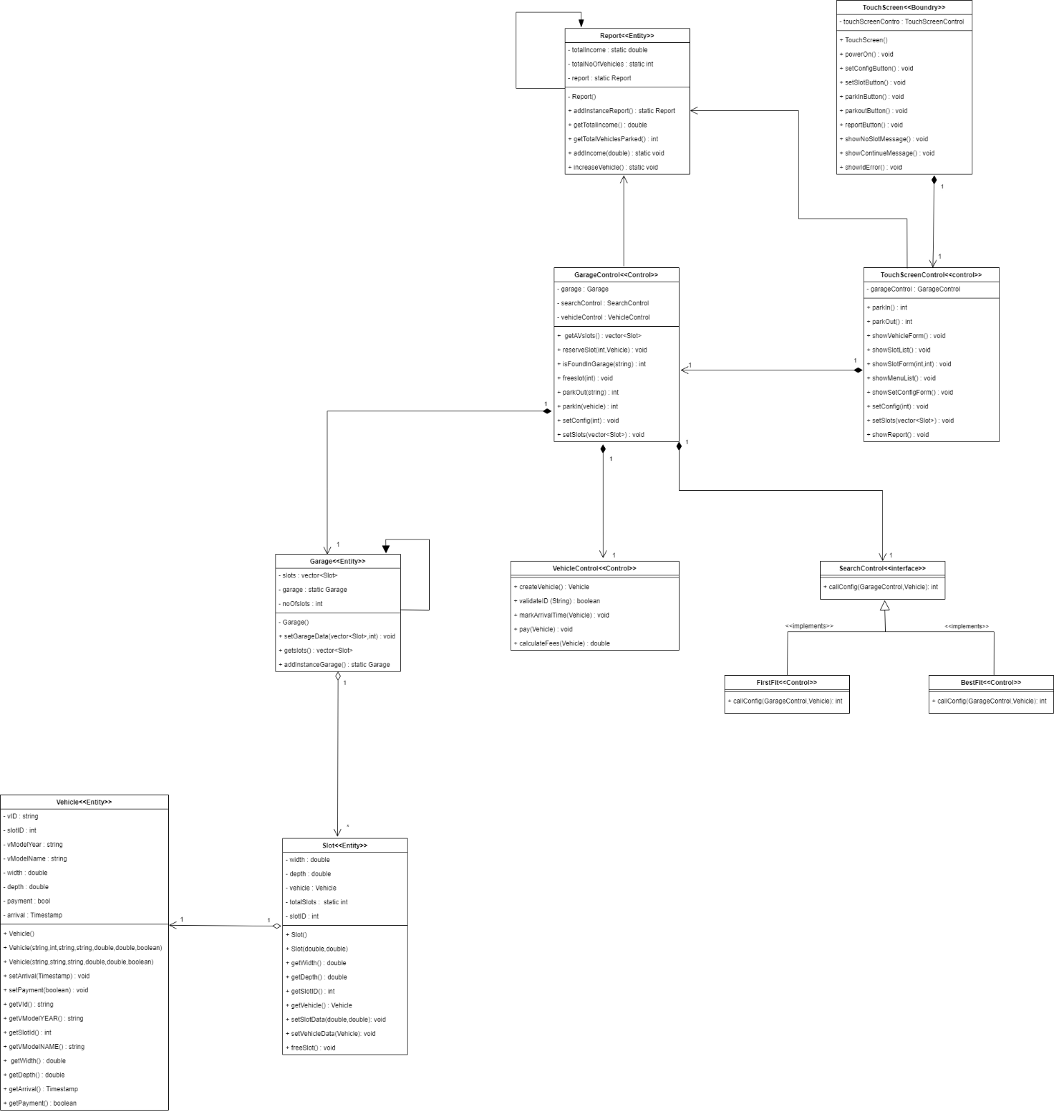

| **Class ID** | **Class Name** | **Description & Responsibility** |
| --- | --- | --- |
| 1 | TouchScreen | Boundary class has responsibility for printing functions and take inputs |
| 2 | TouchScreenControl | Control class responsible foe any operation in TouchScreen (Boundary class) |
| 3 | Garage | Entity class to storage garage data and number of slots. |
| 4 | GarageControl | Control class responsible for park in and out vehical and get available slots |
| 5 | SearchControl | control class responsible for determining which searching algorithm will work while system running |
| 6 | Report | Entity class to update income after every park-out and generate detailed report |
| 7 | Vehicle | Entity object to store car info. |
| 8 | VehicleControl | Control class responsible for calculate fees and check validate vehicle data |
| 9 | Slot | Entity object to storage slot width and depth and slot status (Free/reserved). |

## II. Sequence diagrams

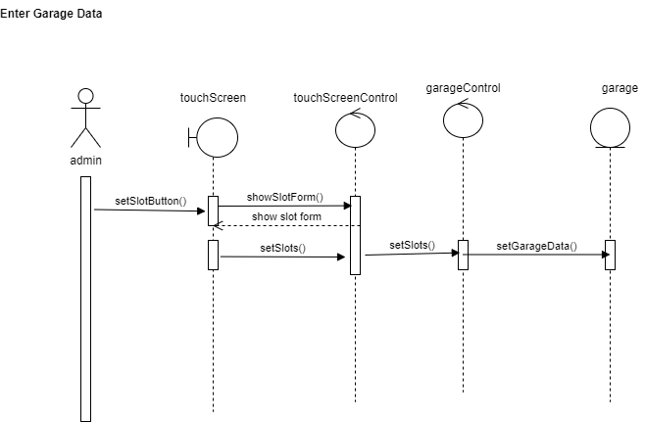

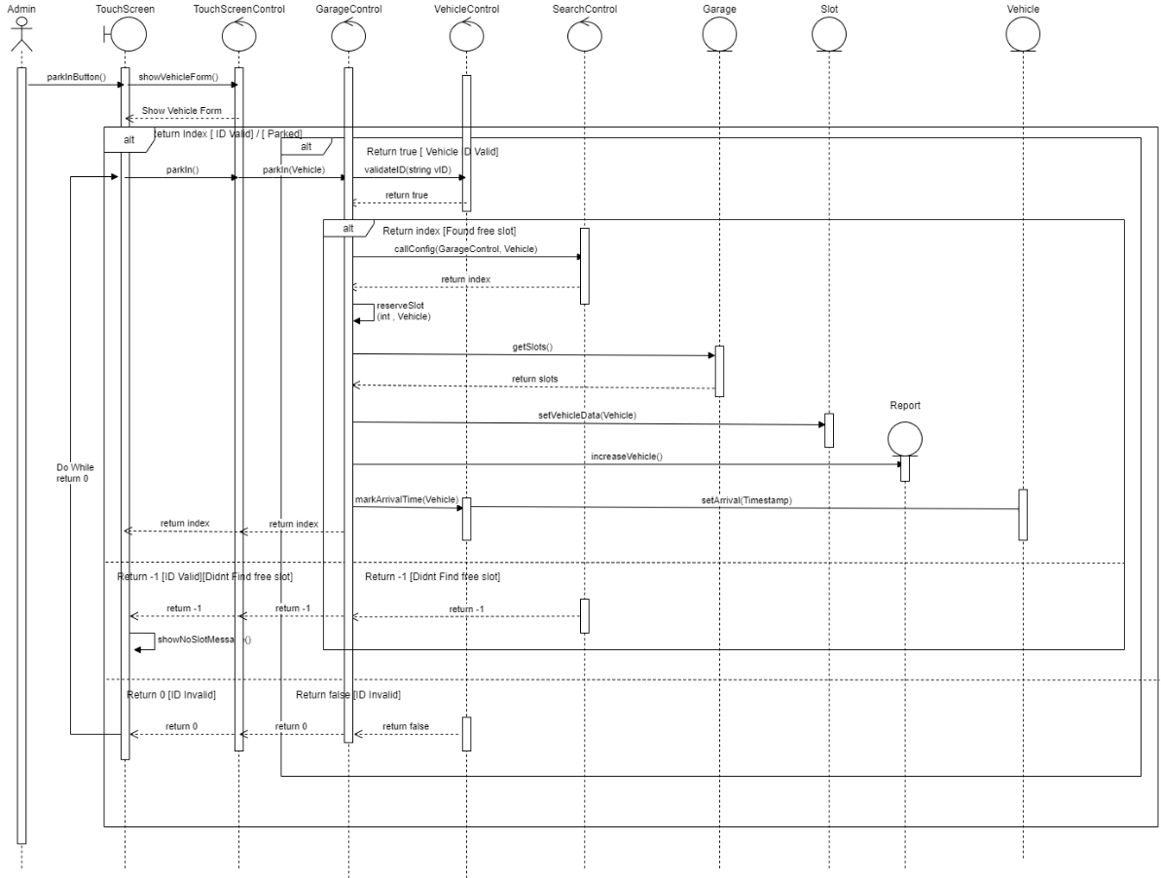

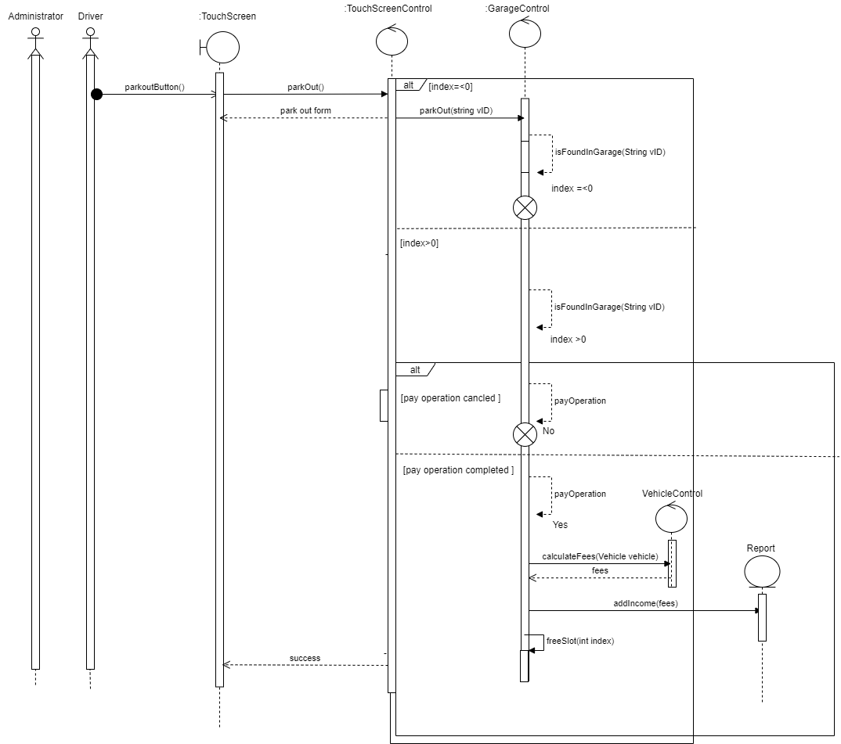

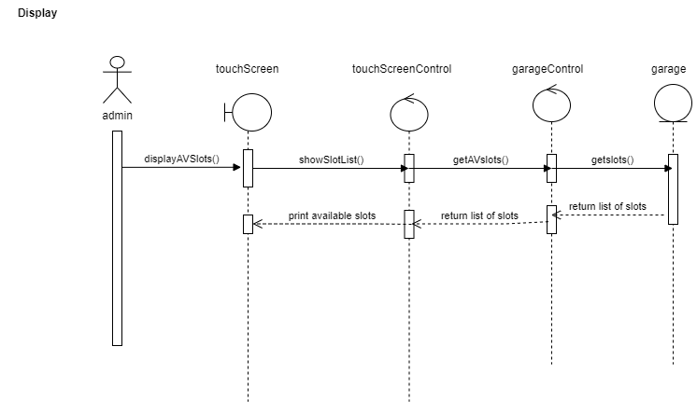

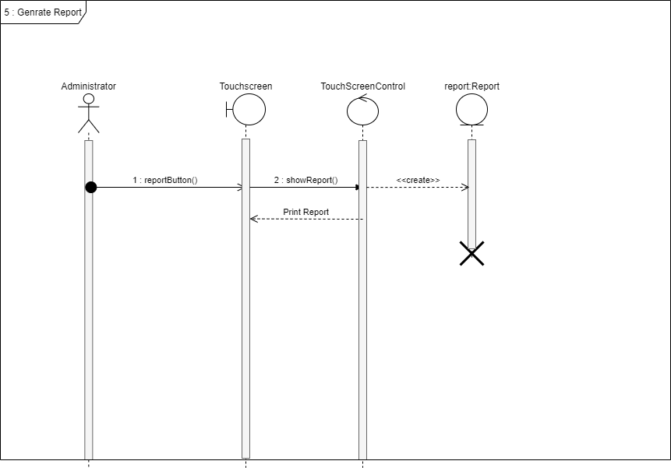

### Class - Sequence Usage Table

| **Class Name** | **Sequence Diagrams** | **Overall used methods** |
| --- | --- | --- |
| 1. TouchScreen | 1, 2, 3, 4, 5 | powerOn, setConfigButton, setSlotButton, parkInButton, parkOutButton, reportButton, showNoSlotMessage, showConfigMessage,  showIdError |
| 1. TouchScreenControl | 1, 2, 3, 4, 5 | parkIn, showVehicleForm, showSlotList, showMenuList, showSlotForm, showSetConfigForm, setConfig, setSlots, showReport |
| 1. Garage | 1, 2, 4 | addInstanceGarage, setGarageData, getSlots |
| 1. GarageControl | 1, 2, 3, 4 | getAVslots, reserveSlot, parkIn, isFoundGarage, freeSlot, parkOut, setConfig, setSlots |
| 1. Vehicle | 2, | setVehicleData, setArrival, setPayment, getVId, getSlotId, getVModelYEAR, getVModelName, getWidth, getDepth, getPayment, getArrival |
| 1. VehicleControl | 2, 3, | validateID, markArrivalTime, Pay, calculateFees |
| 1. Report | 2, 3, 5 | addInstanceReport, getTotalIncome, getTotalVehiclesParked, addIncome, increaseVehicle |
| 1. Slot | 2 | getWidth, getDepth, getSlotID, getVehicle, setSlotData, setVehicleData, freeSlot |
| 1. BestFit | 2 | callConfig |
| 1. FirstFit | 2 | callConfig |
| 1. SearchControl | 2, | callConfig |

# 

# Ownership Report

|  |  |
| --- | --- |
| **Item** | **Owners** |
| sd 2: Display | *Hazem adel* |
| sd 5 : generate report | *Mario guirguis* |
| sd 3 : Park in | *Kerolos george* |
| sd 4 : Park out | *Maher mohsen* |

# Policy Regarding Plagiarism:

1. تشجع الكلية على مناقشة الأفكار و تبادل المعلومات و مناقشات الطلاب حيث يعتبر هذا جوهريا لعملية تعليمية سليمة
2. ساعد زملاءك على قدر ما تستطيع و حل لهم مشاكلهم فى الكود و لكن تبادل الحلول غير مقبول و يعتبر غشا.
3. أى حل يتشابه مع أى حل آخر بدرجة تقطع بأنهما منقولان من نفس المصدر سيعتبر أن صاحبيهما قد قاما بالغش.
4. قد توجد على النت برامج مشابهة لما نكتبه هنا أى نسخ من على النت يعتبر غشا يحاسب عليه صاحبه.
5. إذا لم تكن متأكدا أن فعلا ما يعد غشا فلتسأل المعيد أو أستاذ المادة.
6. فى حالة ثبوت الغش سيأخذ الطالب سالب درجة المسألة ، و فى حالة تكرار الغش سيرسب الطالب فى المقرر.